CS-008 Resins, Mixing & Cure Schedules
Doc ID | CS-008
Title | Resins, Mixing & Cure Schedules
Revision | D
Status | Draft, pending Lead signature
Effective date | 2026-08-28
Supersedes | Ratio/pot-life tribal knowledge

Approvals
Role | Name | Date
Author | Simon Starbuck (drafted with Claude, SN6 Resources) | 2026-07-12
Reviewer | simon (reviewer agent)
Approver (Composites Lead)

Revision history
Rev | Date | Author | Description of change
A | 2026-07-12 | Claude | Initial outline, the one-page ratio/cure table every other standard cites
B | 2026-07-28 | Claude | Language pass: fewer em dashes for rhythm variety, no content change.
C | 2026-08-01 | Claude | Added the FEB hold column to §5 and new §5.1. The app now blocks a work order's demould step until the hold elapses, so the standard and the app were stating different rules; this makes the standard the one that is written down. The holds are team margins over the datasheet, signed off by Simon Starbuck 2026-08-01, and §5.1 says so rather than letting them read as manufacturer figures.
D | 2026-08-28 | Claude | Engineering pass (CS-000 Rev C conventions), and out of outline: §4's one-line definition list written out, §7 retitled from "(outline)" since its steps have been the real procedure since Rev C. Figure 1 puts the datasheet-versus-hold comparison on one time axis, which is where "FAST does not buy a same-day demould" becomes visible rather than asserted. No number changed.

1. Purpose
One table for every resin we stock: ratios, pot lives, cure/demould times, plus the mixing discipline and exotherm rules that apply to all of them. Exists because of soft-spot failures (bad ratios), the first forged-CF part cracking from resin starvation, and a few too many hot cups.

2. Scope
All team resin systems. Process-specific use lives in CS-004 (XCR), CS-006 (IN2), CS-007 (West 105).

3. References
Ref | Document | Where
R1 | IN2 TDS · R2 XCR TDS · R3 West 105/205, /206, /209 TDS | 04 Datasheets/ (see INDEX.md)
R4 | SDS for all of the above | 04 Datasheets/
R5 | Forged/Compression Molded CF study (mix math, starvation failure) | SN5 Composites/Documentation/Forged_Compression Molded Carbon Fiber.docx

4. Definitions
- Pot life: usable time in the mixing pot, at the mass and temperature the TDS states it for. Bigger batch or warmer shop means shorter; the quoted figure is the ceiling, not a promise.
- Gel: the resin no longer flows. Gel is not cure: a gelled part pried off a mold drags resin with it.
- Demould: the earliest the part can leave the mold without damage. Two columns in §5: the manufacturer's figure and the FEB hold that governs (§5.1).
- Full cure: full mechanical properties. Weeks, not hours, for every system we stock; no structural or fit loading before then where avoidable.
- Exotherm: the cure reaction's own heat. Mass concentrated in a cup accelerates it; the runaway case is §6's hot-cup rule.

5. Equipment & Materials: THE TABLE (verify each against its TDS before signing)
System | Ratio (by weight) | Pot life | Demould (datasheet) | FEB hold | Full properties | Use
IN2 + AT30 SLOW | 100:30 | 120–150 min @25 °C | 18–24 h | 48 h | ≥14 d @25 °C | Infusion default (CS-006)
IN2 + AT30 FAST | 100:30 | 10–14 min @25 °C | 6–8 h | 24 h | ≥14 d | Small infusions only
West 105 + 206 SLOW | 5.36:1 (5:1 by volume pumps) | 20–25 min @72 °F | thin-film solid 10–15 h | 24 h | days | Wet layup default (CS-007)
West 105 + 205 FAST | 5.19:1 (5:1 by volume) | 9–12 min @72 °F | 6–8 h | 24 h | days | Small wet layups, tabs
West 105 + 209 | 3.68:1 (3:1 by volume; DIFFERENT pump ratio than 205/206!) | 40–50 min @72 °F (100 g) | thin-film solid 20–24 h | 36 h | max strength 4–9 d; min temp 70 °F | Hot-day / very large wet layups
XCR | 100:41 (2:1 by volume) | 8 min @20 °C (150 g) | 8.5 h initial | 12 h | ≥14 d @20 °C | Mold sealing (CS-004)

5.1 The two demould columns, and which one is the rule
Demould (datasheet) is what the manufacturer publishes, at the temperature
they publish it at. Every figure is quoted from a TDS in 04 Datasheets/.
FEB hold is what this team waits, and it is the one that governs. It is
longer than the datasheet in every row, on purpose, and it is a team decision
rather than a manufacturer claim, so it is never presented as one. Signed off
by Simon Starbuck, 2026-08-01.
The holds are shift boundaries, not multiples of the datasheet: 24 h means "come
back tomorrow" and 48 h means "come back after the weekend". A hold that expires
at 3 am helps nobody, because nobody is at RFS at 3 am. That is why the ratios
against the datasheet look uneven (1.3× for XCR, 3× for the FAST systems); they
were never derived from it.
Two consequences worth knowing before you pick a hardener:
- Both FAST systems hold 24 h. Buying FAST hardener to turn two infusions
round in one day does not work under this rule. That is deliberate: we have no
record of a part ruined by waiting and several of work being rushed. But it is
the line to revisit if the trade stops being worth it.
- A cold shop is not covered by these numbers. Every figure assumes the
reference temperature in its row. We cure ambient with no oven, and RFS in
January is not 25 °C. Log the temperature per §7.5 and fingernail-test the
flange (§8) rather than trusting the clock.
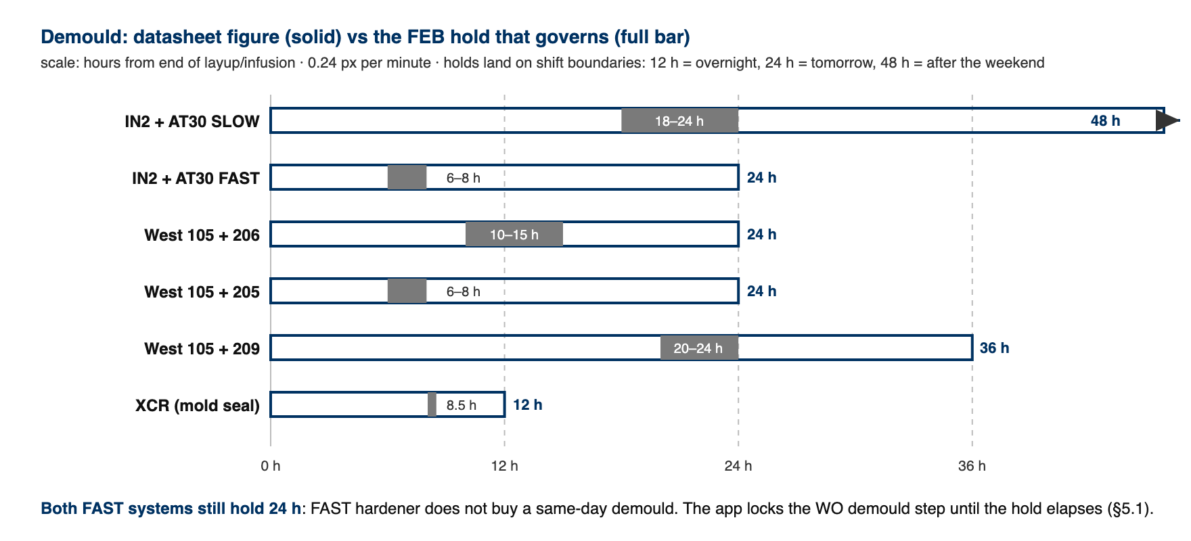
Figure 1. Datasheet demould figure (solid) against the FEB hold that governs (full bar), per system, on one time axis. The holds land on shift boundaries, which is why both FAST systems still hold 24 h.

The app enforces this. A work order's demould step stays locked until the FEB
hold has elapsed from the recorded end of the layup or infusion, and the resin
and shop temperature are captured at that buy-off. A lead may override, but must
type a reason, which is written to the work order's event log with their name and
how many hours short it was. The numbers live in one place, 03 App/app/resins.js,
and a hold shorter than its datasheet figure is rejected by a test.

6. Safety: exotherm and sensitization (applies to every system)
- All epoxies here are skin/respiratory sensitizers (R4): nitrile gloves, ventilation, wash skin with soap not solvent, A-filter respirator for long/enclosed sessions.
- Exotherm rules: mix the smallest batch that does the job; pour out of the pot promptly (mass concentrated in a cup accelerates); a warm cup = use immediately or spread thin; a hot/smoking cup = carry outside onto concrete and leave it. Do not bin, do not water-dilute indoors. Nothing goes in the trash until fully cured and cool.
- Never mix off-ratio to "speed up" or "slow down" cure. Blend hardener speeds (same total ratio, per R1/R3) instead; off-ratio = uncured sticky part.

7. Procedure
- Pick the system from §5 by process standard; confirm pot life fits the job + a margin.
⚠ 209 uses 3:1 pumps, not the 5:1 pumps used by 205/206. Check the pump head before stroking; this is the classic wrong-ratio trap.
- Weigh (scale, 1 g) or pump (West, full strokes only); record masses on the WO.
- Mix ≥2 min scraping walls/base; double-pot (transfer + remix, fresh stick) for anything going on a part surface.
- Forged CF mix math (R5): carbon mass ≈ mold volume × 1.4 g/cc; resin ≈ fiber × 1.25. Starving the mix made the first part brittle (failed bend test); don't eyeball it.
- Cure at ≥20 °C wherever possible; log ambient temp on the WO when it isn't (cold cures run long; see each TDS).
- Do not demould before the FEB hold in §5 has elapsed, counted from the end of the layup or infusion. The work order enforces this and records the resin, the finish time and the shop temperature; it is a lead call to go early, and the reason is logged. Gel is not cure: fingernail-test the flange (§8) before you trust either the clock or the feel of the part.
- Leftovers: spread thin on scrap or leave outside to cure; label per CS-001.

8. Quality checks / acceptance criteria
Check | Target | Method | Record where
Ratio | Weighed/pumped per §5, recorded | Scale/pump count | WO
No soft spots at demould | Fingernail test on flange/trim zone | Manual | WO qualityChecks
FEB hold observed | Elapsed before demould, or overridden with a logged reason | WO step buy-off | WO steps / event log

9. Records
Batch masses, system + hardener speed, ambient temp, cure duration: on every WO that consumes resin. The resin, the finish time and the shop temperature are captured by the work order at the layup or infusion buy-off, so this is a byproduct of running the job rather than a separate write-up.

